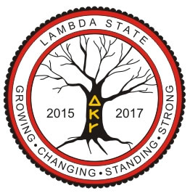

The Delta Kappa Gamma Society International Illinois Lambda State Convention April 15-17, 2016
The Decatur Conference Center and Hotel, 4191 US 36 West, Decatur, IL 62522 Hotel Toll Free Lambda State, Growing, Changing, Standing Strong
Pre-registration Friday Night Session Standing Strong: Card Workshop
Participants will make four cards using die cuts and stamps
Fee:$5.00

Name: Chapter:

Address:

Phone: E-mail:

Make checks payable to DKG, Lambda State. Mail Check and registration form to: Sue Dion - 139 Barrington Lane, East Peoria, IL 61611

