
Illinois, Lambda State Organization

M. Josephine O’Neil Arts Award

IN RECOGNITION OF OUTSTANDING ACCOMPLISHMENT
AND THE ENCOURAGEMENT OF CONTINUED INVOLVEMENT IN THE ARTS

~~~~~~~~~~~~~~~~~~~~~~~~~~~~~~~~~~~~~~~~~~~~~~~~~~~~~~~~~~~~~~~~~~~~~~~~~~~~~~~~

In honor of this dedicated educator

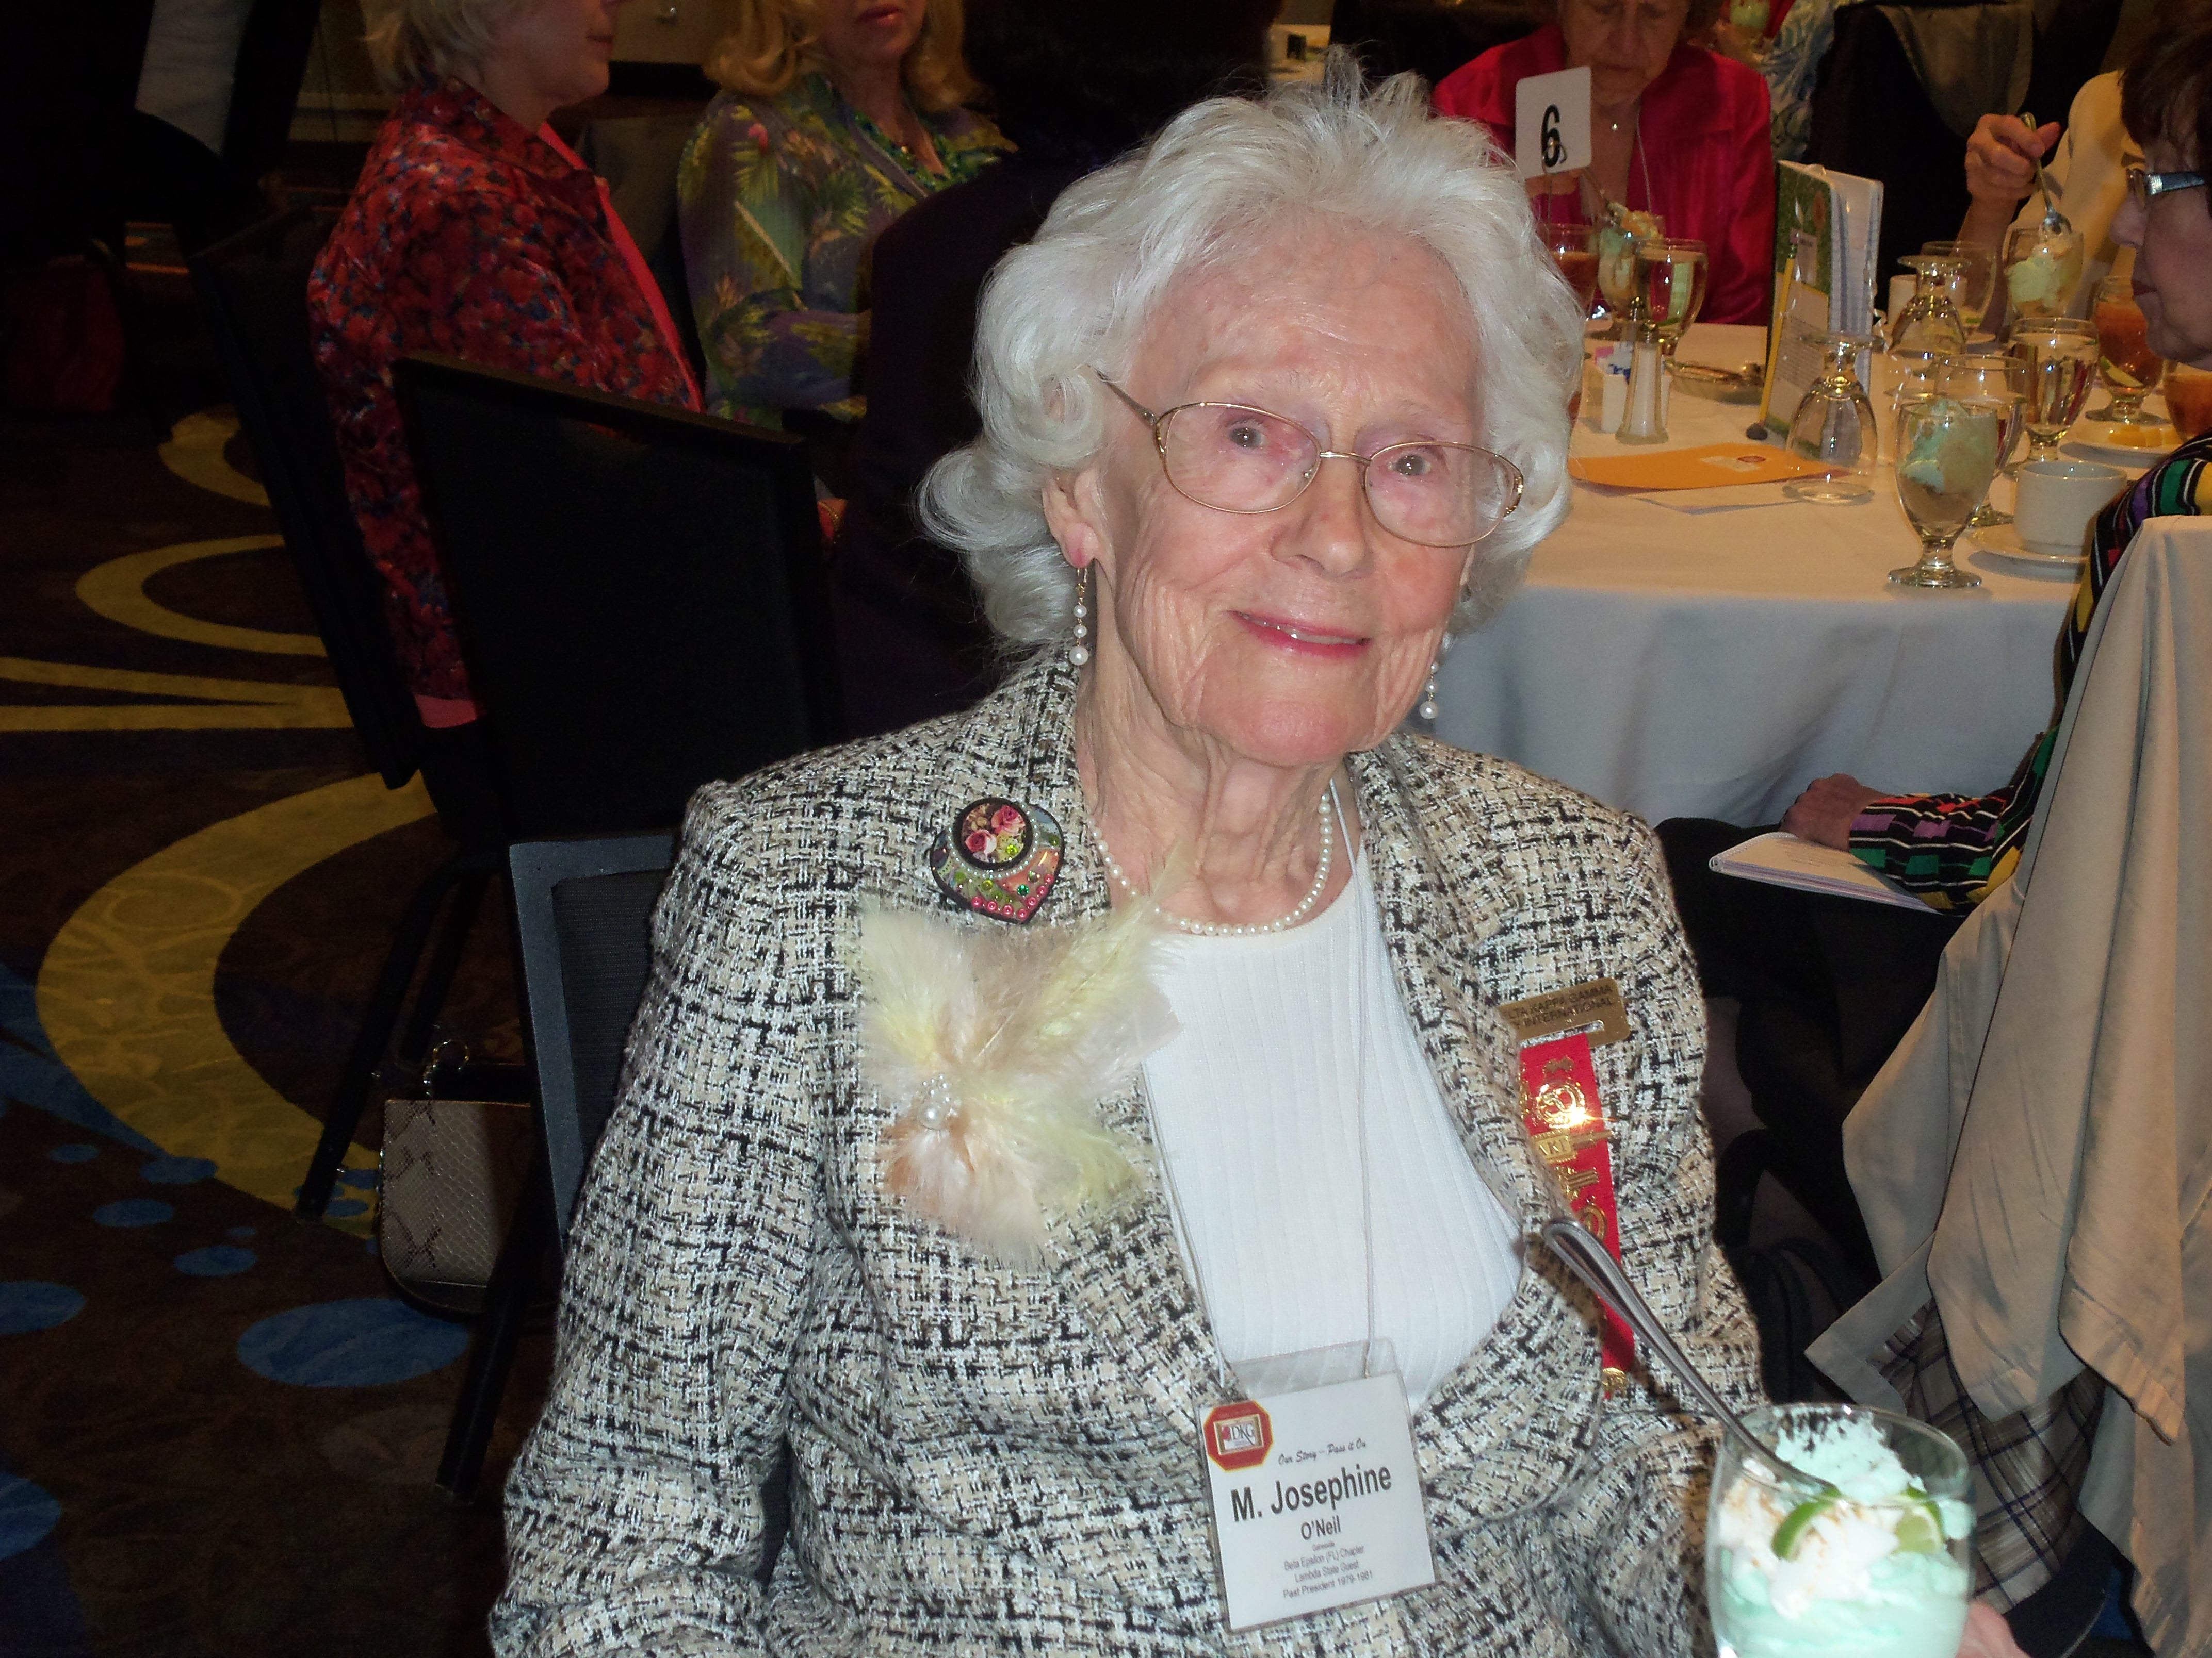

M. Josephine O’Neil

~~~~~~~~~~~~~~~~~~~~~~~~~~~~~~~~~~~~~~~~~~~~~~~~~~~~~~~~~~~~~~~~~~~~~~~~~~~~~~~~

* In 1977, M. Josephine O’Neil and Dr. Carolyn Allrutz conceived the idea of Women in the Arts as a viable committee. In the beginning, it was an Ad Hoc Committee.
* Josephine was Lambda State President from 1979-81. In 1979 a positive vote from the Lambda State Executive Board established the WIA committee.
*In 1981, thanks to M. Josephine O’Neil, an arts award was established and continues to be given to honor young women pursuing a career in one of the arts.
* In 1981, the first arts award was given. The recipient has gone on to an amazing musical career as a professional singer in New York.
* In 2013, at the age of 100 years old, Josephine O’Neil attended her last Lambda State Convention, before passing away. We remember and honor her by continuing the M. Josephine O’Neil Arts Award in her memory.


Thank you for your interest in applying for the M. Josephine O’Neil Arts Award. The Lambda State Organization of The Delta Kappa Gamma Society International grants the award. DKG is an educational honorary Society of key women educators from 17 member countries. Membership is by invitation and is extended to women educators who have demonstrated leadership potential and other qualities reflecting excellence.

Awards totaling up to $6,000.00 are available. The award is funded by the membership and will be presented at the Lambda State Convention in April. A Lambda State Chapter must recommend applicants. If you are not aware of local chapter, please contact Lambda State Women in the Arts Chair Athena Columbus at athenac13@comcast.net.

The purpose of this award is to recognize an outstanding female majoring in one or more areas of the arts (music, visual arts, dance, theater) and to encourage continued involvement in the arts.

Please read the following submission requirements carefully and follow the guidelines to ensure a qualifying application. As an applicant you are responsible for monitoring the timely submission of your application. The deadline for the application submission is February 1. Acknowledgement of your submission will follow the arrival of all application components via email. It is your responsibility to monitor this process, so if you have not received verification, please contact me at athenac13@comcast.net

Eligibility Criteria

To be eligible for the M. Josephine O’Neil Arts Award, a candidate MUST be:

- Female
- A legal resident of Illinois
- In or approaching her junior year at an accredited college/ university, MAJORING in one or more of the arts – music, dance, theater, visual arts
- Recommended by a local Lambda State Chapter
Application Criteria

Your Application Packet MUST Include ALL of the following:
Application will not be considered if any components are not included upon entry
One copy of all materials should be submitted in pdf format to athenac13@comcast.net; Evidence and examples of work may be submitted through postal mail to
Athena Columbus, 8127 N. Oketo Ave, Niles, IL. 60714-2941

1) Personally created cover sheet that includes your name, date, and reflects your personality;

2) M. Josephine O’Neil Arts Award Application;

3) Official college transcript;

4) Two letters of recommendation by college/university personnel;

5) A letter of recommendation by sponsoring Delta Kappa Gamma, Lambda State Chapter President or Designee;

6) Personal essay discussing short and long term goals, philosophy, personal interests, and family; (not to exceed two double-spaced typed pages);

7) Evidence that will best exemplify the quality and extent of accomplishment in one or more areas of the arts such as programs of performances, catalogs, articles from the media, published reviews of the individual’s work, and a listing of awards, prizes, honors, or other recognition (may be sent through postal mail);

8) Recent examples of work (may be sent through postal mail):
Visual samples: (3-10) includes title, medium, and dimensions (1024 pixels on the longest side and in JPEG format)
Varied dramatic, musical or dance samples (1-2) in the form of high quality DVD or CD, representative of the applicant’s fluency/flexibility that focuses on the applicant’s “solo” performance: (not to exceed five minutes in length)

9) Statement and discussion of use of the Award to continue involvement in your selected areas of the arts

10) Initialed Statement of Availability to attend the Lambda State Convention Awards Breakfast in April.
Replace this page with
1) Personally created cover sheet
M. Josephine O’Neil Arts Award Application
(Must be submitted electronically in pdf format to athenac13@comcast.net)

Date |  | Recommending Chapter:
Last Name | First Name |  | Middle Name
Address:  Street | City |  | State | Zip
Permanent address if different from above
Street | City |  | State | Zip
Birth date |  | Telephone (include area code)
Email

Current enrollment in college, university, or community college
Name of University/College |  | Entrance date
University/College address
Street | City |  | State | Zip
Major area of study

Minor area of study

What date did you, or will you become a junior?

Indicate area or areas of the arts in which you have achieved outstanding accomplishments (Check the appropriate areas):

Music: Voice Instrument (indicate type)

Dance (specify)

Theater (specify)

Visual Arts (specify)

Personal Essay: Discuss short and long term goals, philosophy, personal interests, and family; (not to exceed two double-spaced typed pages)

Recent examples of work: Check type of evidence being submitted (electronically or through postal mail.) Work should be labeled with a completion date. Keep in mind that audio and video submissions MUST NOT exceed five (5) minutes in length and other visual works MUST NOT exceed ten (10) in number.

Visual samples

DVD (Identify the “performance” and/or artwork to be viewed indicating title of work, medium, date(s) of completion below)

CD (Number each work indicating title of work, medium, date of completion below)

Statement of Continued Use: How will you use this award to continue your involvement in your selected area of the arts?

Statement of Availability: Please read the statements below and initial (electronically) on the line provided.

If selected, I understand that I am encouraged to attend the Awards Breakfast at the Lambda State Convention on Sunday, April 23, 2017 at the Hotel Frontenac St. Louis in St. Louis, Mo. I should bring a small display of artwork or plan a short performance.

If selected, I grant permission that my name and/or photo may be used in publicity releases, Newscaster (Lambda State newsletter) and Lambda State Website.

I hereby submit for consideration this application for the Delta Kappa Gamma Society International, Lambda State M. Josephine Arts Award. I have answered the questions accurately, to the best of my knowledge.

Signature of Applicant Date
(Electronic signature is acceptable)

All enclosures must be typed, word processed, or computer generated.

One completed packet must be postmarked/dated by February 1, 2017.

Send complete electronic application to Athena Columbus athenac13@comcast.net
Send evidence of accomplishments and recent examples of work to Athena Columbus, 8127 N. Oketo Ave, Niles, IL 60714-2941
Applications will be evaluated by a committee that includes at least one expert from each of the arts listed in the application. Committee member will use the following rubric with the possible total number of points for each component:

The Rubric for the M. Josephine O’Neil Arts Award 2017

1. Cover Sheet, Data, and Clarity of Application

(5 points possible)

2. Academic Achievement (transcripts, grades, & course of study)

(20 points possible)

3. Letters of Recommendation (college/university personnel & chapter president or chapter president’s designee)

(20 points possible)

4. Personal Essay (short and long term goals, philosophy, achievements, awards, personal interests, and family - not to exceed two pages, double spaced)

(20 points possible)

5. Use of Award (statement and discussion of the use of the award to continue involvement in the selected area of art)

(10 points possible)

6. Example(s) of Applicant’s Work (this evaluation will be done at a meeting of the committee as a whole and discussion will ensue to find consensus)

(25 points possible)

