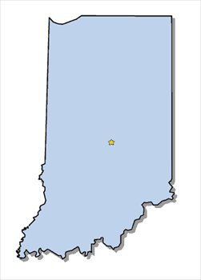
The Delta Kappa Gamma Society International
Indiana 2014 International Convention Sponsorship

The Indiana 2014 International Convention Steering Committee is offering sponsorships to individual members, chapters, and businesses in support of the 2014 Indiana International Convention Fund. Sponsorships support Indiana Night
by providing approximately 2,000 attendees with quality entertainment and favors
that evening.

The 2014 International Convention becomes a reality next July and it is vital that more money is raised. As of August 2013, the fund has grown to $10,557.00, and your generous contributions have been greatly appreciated. Just as Indy race car drivers strive to finish the race and reach the checkered flag, the Indiana state organization strives to finish its fundraising. Sponsors of the Indiana 2014 International Convention will be able to select their level of involvement that corresponds with the Indy racing flags.

You are encouraged to participate through donations, even securing local business donations. Chapters, individuals, and local businesses choosing to become sponsors will have their names printed in the Indiana Night Program. Simply fill out the form below by May 1, 2014, indicating your level of sponsorship, write your check payable to the Indiana 2014 International Convention, and remit to:

Jo Ann Manes, Convention Treasurer
Indiana 2014 International Convention
2351 Foliage Lane
Dyer, IN 46311-1978
________________________________________________________________________
Indiana 2014 International Convention Fund

Please print.
Name _________________________________________ Chapter ___________________

Name to be printed in program booklet ________________________________________

Address __________________________________________________________________

City, State, Zip _____________________________________________________________

Phone _(_____)__________________ E-Mail ____________________________________

Level of Sponsorship _____ Indianapolis 500 Club $500+
_____ Brickyard 400 Club $400
_____ Winners Circle Club $300
_____ Gasoline Alley Club $200
_____ Checkered Flag Club $100
_____ White Flag Club $ 75
_____ Green Flag Club $ 50
_____ Yellow Flag Club $ 25

