**DELTA KAPPA GAMMMA SOCIETY INTERNATIONAL**

**ALPHA EPSILON STATE**

**Alpha Pi Chapter**

May 2016 __________ ­­ Vol. 67, No. 10

**FROM THE PRESIDENT**

Dear DKG Sisters,

Finally, spring has arrived! I hope that you have been able to enjoy some of the beautiful, warm weather we have been having! I just love walking around my home outside to see all the new plants and flowers that are starting to sprout and push out their buds and flowers! I also find it hard to believe that school will be out the middle of May! I can't ever remember getting out this early!

 I want to thank you for the privilege of serving as your president the past two years.  I hope that you feel we have made some positive changes in the way we do our meetings and that the meetings have been meaningful to you. I appreciate the help I received from the executive board also. I hope that everyone will continue to support Bonnie and her officers in the next two years by doing your part on the different committees that we have and keep Alpha Pi strong and healthy.

Last Saturday, Julie Reef, Cindy Sprunger, Bonnie Stewart, and I attended the state convention in Terre Haute. We had a great time renewing acquaintances with other DKG members from around the state, went to break out sessions, and had a lovely luncheon. We heard Mike Lunsford, a teacher and writer, who encouraged us to "Keep making impressions." Our words and actions speak loudly, and we never know what impact we might have on our students!

At our meeting on May 14, we will be celebrating Founders Day, and our state president, JoAnn Manes, will be joining us and participating in our skit. She will be coming to us from Dyer, Indiana. Please be sure to welcome her! Oh yes, and don't forget to wear a hat to our tea! It was not uncommon for the founding ladies to wear a hat to their DKG meetings!

See you soon! Karen

**MAY MEETING**

May 14 9:00 A.M.

Executive Board 8:30 A.M.

Cross Community Church

315 W. Main Street, Berne, IN

(Enter through the east door.)

Brunch $7.00

Program: “Hats off to our Delta Kappa Gamma Founders.” Please wear a hat to our tea!

Roll Call: What is your favorite tea or not?

Project: Adult size socks for the homeless

**COMMUNICATIONS COMMITTEE:** Please get the names of those planning to attend



the May 14 meeting to Karen Moser

by **Saturday, May 7**.

Thank you for your dedicated efforts to help

us be efficient in our planning.

**2016 STATE CONVENTION**

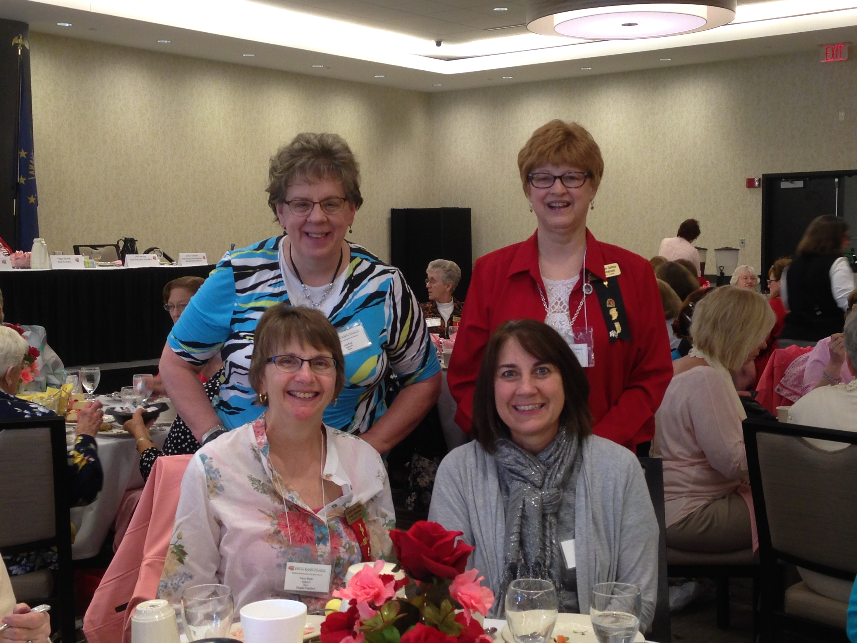

Julie Reef, Bonnie Stewart, Karen Moser, and Cindy Sprunger represented Alpha Pi at our recent State Convention.

**DATES TO REMEMBER**

* Chapter Committee and Officers Training (CCOT) June 18 in Lafayette, IN
* 2016 DKG International Convention

July 5-9 in Nashville, TN

#### 2016-2018 OFFICERS

We will be voting on and installing our new officers for the new biennium 2016-2018.

**President**: Bonnie Stewart

**First Vice President**: Connie Hidy

**Second Vice President**:

**Recording Secretary**: Marilyn Harvey

**Corresponding Secretary**: Emily Cook

Thank you ladies for your willingness to lead us for the next two years!

We are still looking for someone to fill the second vice-president's position. The first term this person is an observer of how things operate. The second term you would be responsible to update the yearbook. The third term is when you serve as president. Please consider this position as we will need a president to lead us in 2020-2022.

----Karen

**GRANT-in-AID RECIPIENTS**

This year’s Grant-in-Aid recipients include students from Adams Central and South Adams.

Lydia Johnson graduated from Adams Central and will graduate from Huntington University in May of 2017 with a degree in elementary education/special education. A few of her school activities include Kappa Delta Pi, Campus Ministry Coordinator, student admissions staff, and children's church mentor for an autistic boy. Her hobbies include tennis, baking, hanging with her friends, and reading.

Jenna Smith graduated from South Adams High School. She   will graduate next December from Manchester University with a Secondary Education degree in Chemistry. Jenna was a founding organizer of Delight Group, a Christian Fellowship for Women.

**UPCOMING CHAIRPERSONS**

The following members will be meeting chairpersons for the coming year:

Blackford/Southern Wells  
Jeni Meeks---November 2016  
Jill Markley---January 2017  
  
Bluffton/Northern Wells  
Marcia Hotopp---January 2017

Susan Ballinger---March 2017  
  
South Adams

Gwen Habegger---January 2017  
Julie Reef---May 2017

Adams Central/North Adams  
Susann Gilbert---January 2017

Carol Pettibone---September 2017

Contact Bonnie Stewart with questions.

765-289-2966 or 765-744-3227

**GOING GREEN**

At our last meeting, a number of you signed up to "go green" to receive our Hoosier Newsette. If you gave me your school address, I will need your home address. The state news editor, Marti Dailey, is concerned that newsletters going to school will not get to you. If you have not signed up to "go green," you may still do so. See Karen at our May meeting.

**SCHOLARSHIPS and GRANTS**

* Scholarships

There are eight $1000 scholarships available to aid outstanding women educators in pursuing graduate study. One $1500 scholarship for a guidance/counseling degree or endorsement and one $2500 scholarship for a member who has been admitted to a doctoral program. These applicants must have been a member for at least two years. See the application for more specific requirements.

* Travel/Study Grants

A $350 travel/study grant can be awarded to a member who is 55 years or older, who is willing to write a brief essay about why you chose this particular opportunity to travel and study, and will share what personal growth you want to accomplish.

* Mini Grants

A mini-grant can be awarded in the amount to $500 or less for the professional development of members. These awards are made on the basis of the appropriateness of the member's project. Projects must show promise of making a significant contribution to the candidate's professional growth and to the field of education.

***********************************

Applications may be obtained from the State website: deltakappagamma.org/IN/forms.html. The above information was taken from the  Alpha Epsilon Scholarship brochure.

#### RED ROSES COLUMN



Jane Meshberger is our newest member of Alpha Pi and was initiated at our last meeting. She has taught kindergarten at Southern Wells for over fifteen years. Jane her husband, Jim, have six children, and she enjoys quilting, sewing, and hand crafts. She’s also interested in bees and chickens! Welcome to Alpha Pi, Jane!



Our thanks and appreciation to Karen Moser who has served as our president for the past two years. Karen has taught music at South Adams Elementary for over 30 years and also shares her musical talents by serving as pianist/organist at her church. Karen and her husband, Gregg, have four children and enjoy traveling which will include a trip to Switzerland and France this summer! Karen always found a way to keep us well informed about DKG information and happenings and made our meetings lively and fun, too. We take our “Founders’ Day” hats off to you, Karen, for a job well done.



A big thank you to all who served as officers this past biennium and also to those who were responsible for chairing our meetings during the past year. We appreciate your willingness to serve and help keep Alpha Pi strong.

**HAPPY BIRTHDAY**

**JUNE**

Cindy Sprunger 11

#### Joan Arnold 14

Karrie Hamilton 15

#### JULY



Deb Johnson 6

Judy Minger 16

Christine Zadylak 18

Marcia Hotopp 21

**AUGUST**

Diane Humphrey 9

Jane Meshberger 10

Julie Reef 23

Jaime Macklin 28

**NEWSLETTER INFORMATION**



Thanks to Emily Cook for serving as our new corresponding secretary. Anyone wishing to submit information for the newsletter should do so at least three weeks before the meeting date.

Contact information:

emily_cook18@hotmail.com

6396 E. 225 N. Decatur, IN 46733

260-223-0049

**MISSION STATEMENT**

The Delta Kappa Gamma Society International promotes professional and personal growth of women educators and excellence in education.

